**Social Care Future**

**Summer Update July 2021**

**The Social Care Future vision**

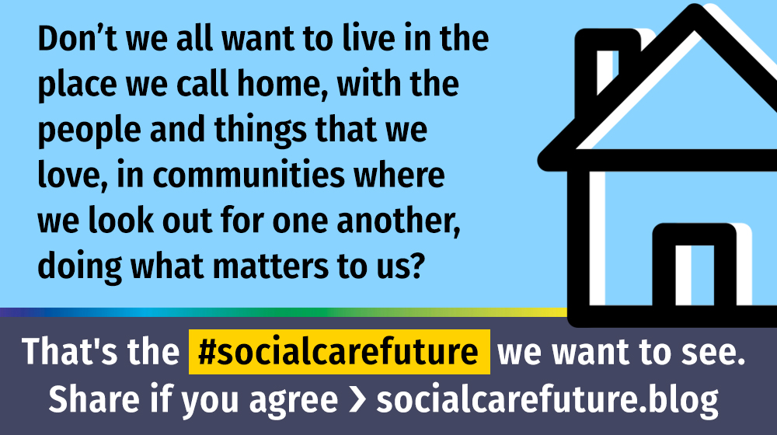

Here is an update on what our movement has been doing and our future plans.

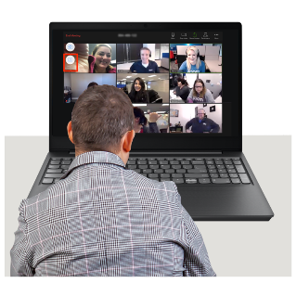

**Spring Gathering**

More than 300 people signed up to come to some great online sessions to help plan and debate bis issues

You can find recordings of all the sessions and slides here: [Catch up with the #socialcarefuture Online Spring Gathering – Social Care Future](https://in-control.org.uk/people-families-communities/national-network-social-care-future/social-care-future-on-line-festival/)

**](https://in-control.org.uk/people-families-communities/national-network-social-care-future/social-care-future-on-line-festival/)** **Whose Social Care is it Anyway Inquiry**

A lot of people have let us know about their experiences and ideas and we have launched the first findings in a report.

You can find copies of the report, including easy read, here: [From permanent lockdown to an equal life (socialcarefuture.blog)](https://socialcarefuture.blog/2021/05/27/from-permanent-lockdown-to-an-equal-life/)

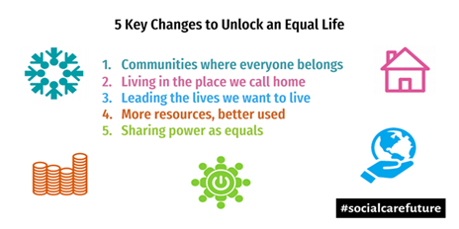The report asks for 5 main changes

We have written to all of the Directors of Adult Social Care to ask if they would think about using the Social Care Future vision and some have already said that they would support it.

**The Pledge – what we are asking people to do**



We want people who organise conferences and events about social care to always make sure that people who use social care attend – or things won’t change.

You can watch what Anna talk about the Pledge – [#oursocialcare – Social Care Future](https://socialcarefuture.blog/2021/02/10/oursocialcare/).

If you want to you can sign the and share the pledge. We are using the hashtag [#OurSocialCare](https://twitter.com/hashtag/OurSocialCare?src=hashtag_click)

**Influencing things – making change happen**

People of the social care future movement look for ways work with others to share the Vision. This includes sharing our views with those in Power.

Recently we have:

* Responded to the Queen’s Speech and the future of social care - [National Adult Social Care Strategic Partners: our response to the 2021 Queen’s Speech (socialcarefuture.blog)](https://socialcarefuture.blog/2021/05/14/response-to-the-2021-queens-speech/)

* Written a letter to the Prime Minister, Chancellor and Health Secretary - [Start reform of social care now – open letter to the Prime Minister (socialcarefuture.blog)](https://socialcarefuture.blog/2021/06/21/start-reform-of-social-care-now-open-letter-to-the-prime-minister-chancellor-of-the-exchequer-secretary-of-state-for-health-social-care-from-social-care-leaders/)

* Anna Severwright was interviewed on Sky News – [Watch Anna here](https://www.linkedin.com/posts/martin-routledge-21a19a2a_here-anna-severwright-convenor-of-social-activity-6813135692068220928-OfrZ/)

* We met with the Department of Health to ask for a better way of working together to develop social care policy for people that use social care.
* We did a survey with local councillors to see how many would support the Social Care Future vision. See [what local Councillors think about the Social Care Future vision here](https://socialcarefuture.blog/2021/06/24/what-do-local-councillors-think-about-socialcarefutures-vision/)

**Communications workshops - How to build public support to make change**

With our partner organisation [Equally Ours](https://www.equallyours.org.uk/strategic-communications/strategic-communications-training/) we will be running some workshops on how to campaign and get our message out to the public about how we can change social care.

The workshops will be in 2 parts:

**Workshop #1**

****Part 1: Tues 21st September 2021, 10am to 12pm

Part 2: Thurs 23rd September 2021, 10am to 12pm

**Workshop #2**

Part 1: Tues 5th October 2021, 10am to 12pm

Part 2: Thurs 7th October 2021, 10am to 12pm

If you would like to attend, please email [socialcarefuture@gmail.com](mailto:socialcarefuture@gmail.com)

**A movement programme for 2021-2**

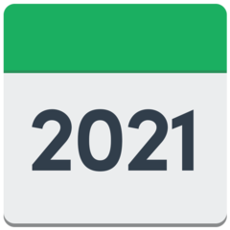

Throughout 2021 we are running activities to turn our vision into actions.

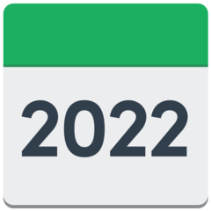We will be back in September to share dates for the next online sessions.

Movement members are invited to help develop and share ideas for the programme – please get in touch with your ideas.

**Keeping in touch**

We are currenly building a new website ready for the Autumn

We have a blog site: socialcarefuture.blog

We are on twitter: @socfuture

We are on Facebook: <https://www.facebook.com/socialcarefuture/>

**A note about funding**

Social Care Future gets no core funding so we can be independent.

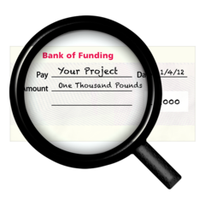Some initiatives are sponsored by movement members “without strings”.

Any funding given to the Social Care Future will be used for movement activity. In particular co-production, movement building and administration.

All programmes are run on a “pay if you can” basis to ensure that anyone can take part.

Donations from groups able to support the movement are welcome.

Thank you

**Best wishes**

**The Social Care Future Convenor Team: Anna, Martin, Neil and Julie**